PHASE 1 — IDEA
Project Purpose
A marketplace LMS where independent instructors create and sell self-paced, structured video/text courses. Students discover, purchase, and complete courses. Platform handles payments end-to-end, including automated instructor payouts.
Target Audience
- Instructors — independent experts/creators monetizing knowledge without building their own infra.
- Students — self-directed learners buying focused courses.
Main Problem Solved
Removes technical/business friction (hosting, payments, discovery, payouts) so instructors can focus on content and students get a trustworthy place to buy it.
Core Goals
- Instructors create & publish courses (sections → lessons).
- Students discover, purchase, and consume courses.
- Automated payment flow: student → platform → Stripe Connect payout to instructor (minus commission).
- Reliable video/content delivery.
- Trust signals via reviews/ratings.
- Basic progress tracking per student per course.
MVP Feature Set
Feature | Included in MVP?
Instructor course creation (sections/lessons, video+text) | ✅
Course publishing/listing | ✅
Course discovery (browse/search/category) | ✅
Checkout & payment (Stripe) | ✅
Automated instructor payouts (Stripe Connect) | ✅
Student dashboard (purchased courses) | ✅
Progress tracking (% complete) | ✅
Admin role — course approval queue, approve/reject with  reason, basic user management. | ✅
Reviews & ratings | ✅
Nice-to-Have (post-MVP, v1.x)
- Certificates of completion
- Coupon codes / promotional pricing
- Basic instructor analytics (views, completion rate)
- Wishlist / save-for-later
Future Versions (v2+)
- Quizzes, assignments, graded content
- Discussion forums per course
- Subscription/bundle pricing models
- Live cohort-based courses (would require a genuinely different architecture — streaming, scheduling)
- Mobile apps
- Course bundles, affiliate program

Functional Requirements
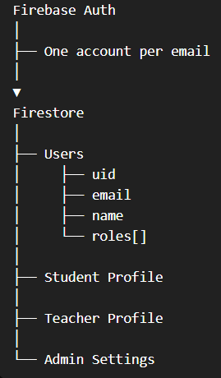
Auth
- Register/login via email+password or Google OAuth
- Single account can hold both student and instructor roles simultaneously (a user isn't locked into one role)
- Password reset flow (for email/password accounts)
Student
- Browse/search/filter courses (category, price, rating)
- View course detail (curriculum preview, reviews, instructor bio)
- Checkout & pay (Stripe)
- Access purchased content; track lesson-level progress (%)
- Leave verified-buyer review/rating
- Dashboard: enrolled courses + progress
Instructor (any user can self-apply for this role)
- Apply to become instructor (simple form/toggle — no admin gate here, per your decision)
- Create/edit courses: sections → lessons, video+text content, pricing, category, thumbnail
- Submit course for admin review
- Connect Stripe (Stripe Connect onboarding) — required before a course can be submitted, since payouts can't work without it
- View own analytics: enrollments, revenue, ratings
- View payout history
Admin
- Review queue: approve/reject courses with reason
- Manage users (view, suspend if needed)
- Manage categories/taxonomy
- Platform analytics: revenue, commission, active users
System-wide
- Email notifications: purchase receipt, course approved/rejected, payout sent, password reset
- Search (course title/description, category filter, price filter, rating sort)

Non-Functional Requirements
This is the part beginners skip entirely, then get surprised when the app is slow, insecure, or unmaintainable under real usage. Non-functional requirements don't describe features — they describe qualities the system must have.
Category | Requirement | Why it matters here
Performance | Course browse/search pages load < 1s p95; video starts playing < 2s | Marketplace UX lives or dies on browse speed — slow discovery = lost sales
Security | No raw card data touches your servers (Stripe handles it); passwords hashed (bcrypt/argon2); RBAC enforced server-side, never trusted from client | You're handling real money and PII — this is non-negotiable, not a nice-to-have
Scalability | Video delivery must scale independently of app servers (CDN-backed) | Video is your biggest bandwidth cost — can't scale it the same way as API traffic
Availability | Target 99.5%+ uptime for MVP (not 99.99% — that's premature for a new product) | Real number, not aspirational — over-engineering for 5-nines uptime on day one wastes effort
Maintainability | Clear separation of concerns (API layer, business logic, data layer); documented API contracts | You'll be iterating fast post-launch; tangled code kills velocity
Accessibility | WCAG 2.1 AA baseline (alt text, keyboard nav, contrast) | Often ignored until a legal/PR problem forces it — cheaper to bake in now
Responsiveness | Fully responsive web (mobile browser usable) — no native app in MVP | Matches your Phase 1 scope decision
Compliance | GDPR-aware data handling (EU users), since you're going international | You said international — this isn't optional, it's a real legal requirement

Key Architectural Decisions (with trade-offs)
1. Monolith vs. Microservices
I'm recommending a modular monolith for MVP, not microservices. Let me justify this rather than just assert it, since it goes against what a lot of tutorials push.
Approach | Pros | Cons
Modular monolith (recommended) | Single deploy, simpler ops, faster to build, easier to reason about transactions (e.g., payment + enrollment happening atomically) | Harder to scale individual pieces independently later (but you can extract services when you actually need to)
Microservices | Independent scaling, team autonomy | Massive overhead for a solo/small team — distributed transactions, service discovery, network failures between services you now have to handle yourself
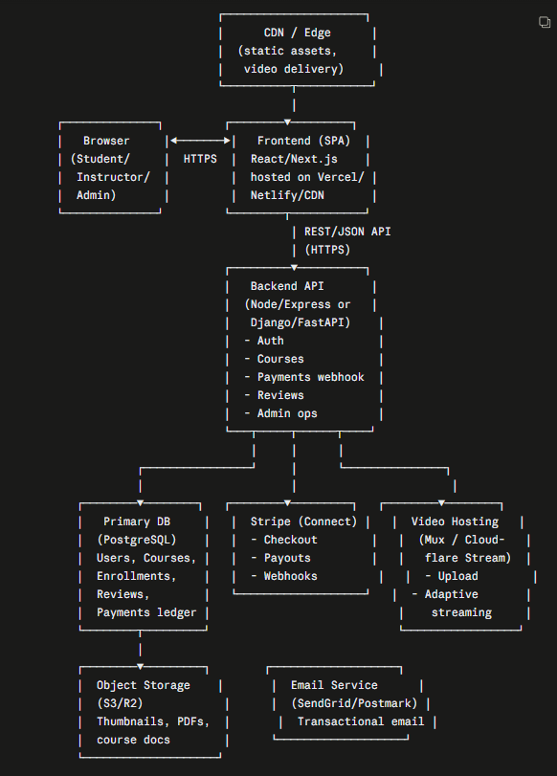
Common beginner mistake: starting with microservices "because it's what big companies use." Big companies adopted microservices to solve organizational scaling problems (100s of engineers stepping on each other), not technical ones. You don't have that problem yet. A modular monolith — clean internal module boundaries (auth, courses, payments, reviews) inside one codebase — gives you 90% of the benefit with a fraction of the operational cost. You can split into services later if and when a specific part (e.g., video processing) genuinely needs independent scaling.
2. Backend stack
I'll present options rather than assume:
Stack | Good fit if...
Node.js (Express/Nest.js) + TypeScript | You want one language across frontend+backend, huge ecosystem, good for I/O-heavy APIs like this
Python (Django/FastAPI) | You want batteries-included admin tooling (Django admin is genuinely great for your admin review queue), strong data/ML ecosystem if you add recommendations later
Ruby on Rails | Fastest to build CRUD-heavy apps like this, mature conventions, less trendy but very productive
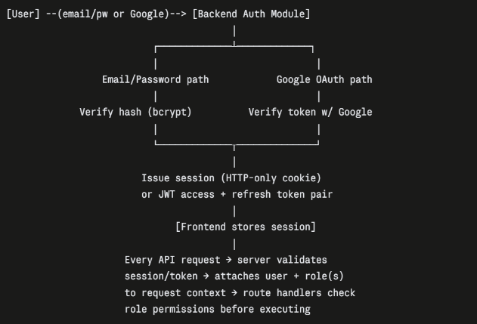
For a marketplace LMS with a heavy admin/CRUD surface (courses, curriculum, review queues, user management), Django has a genuine edge because of its built-in admin panel — you get a working admin interface almost for free, which directly serves your Phase 1 requirement (admin approval queue) without building custom admin UI from scratch. Node/TypeScript is the more common modern choice if your priority is a unified JS/TS codebase with the frontend. I'd lean Django unless you have strong TypeScript preference — but this is genuinely a judgment call, not a hard rule.
3. Frontend
React (Next.js) — recommended. Reasoning: you need SEO for course discovery pages (students find courses via Google), which favors Next.js's server-side rendering over a pure client-side SPA. A plain React SPA would hurt discoverability, which directly undermines your marketplace growth.
4. Database
PostgreSQL — recommended over MongoDB/NoSQL. Reasoning: your data is deeply relational (users ↔ courses ↔ enrollments ↔ payments ↔ reviews, all with real foreign-key integrity needs), and financial/payment data especially benefits from ACID transactions and strong consistency — you do not want eventual consistency on a payments ledger. This isn't close for your use case; Postgres is the right call, not just "a" call.
5. Video hosting — the decision I flagged earlier
Option | Trade-off
Mux | Purpose-built for exactly this (video API, adaptive streaming, analytics). Pay-per-minute-streamed + storage. Easiest integration, best DX. Higher cost at scale.
Cloudflare Stream | Similar to Mux, often cheaper at scale, tightly integrates with Cloudflare CDN. Slightly less polished API/analytics than Mux.
Self-hosted (S3 + CloudFront + custom transcoding) | Cheapest at massive scale, but you now own video transcoding, adaptive bitrate, DRM/anti-piracy — this is a multi-week project on its own. Beginner mistake: underestimating this. Don't do this for MVP.
YouTube unlisted (hack) | Free, but no access control (anyone with the link can view — defeats "paid content" model), no branding control, against many platforms' ToS for commercial resale. Not viable for a paid marketplace.
Recommendation: Mux or Cloudflare Stream for MVP. Self-hosting video is a classic trap — it looks "free" but costs weeks of engineering time for encoding, adaptive streaming, and secure playback (signed URLs so students can't download/redistribute your instructors' paid content).
6. Authentication
Recommend your own auth (email/password) + Google OAuth, using a well-tested library (e.g., Auth.js/NextAuth for Node, or django-allauth for Django) rather than hand-rolling JWT logic. Hand-rolled auth is one of the most common sources of real security vulnerabilities in beginner projects — password reset token leakage, session fixation, improper JWT expiry handling. Use a library; don't reinvent this.
7. File storage (non-video assets)
S3-compatible object storage (AWS S3 or Cloudflare R2 — R2 has no egress fees, worth considering) for thumbnails, instructor documents, PDFs.
I'm recommending HTTP-only cookie sessions over client-stored JWTs for this app, since you're server-rendering with Next.js anyway — cookies are simpler and more secure against XSS token theft than storing JWTs in localStorage (a very common beginner mistake).

Notification System
Simple for MVP: backend triggers transactional emails (SendGrid/Postmark/Resend) on key events — purchase receipt, course approved/rejected, payout sent. No in-app notification center needed for MVP; that's a v2 nice-to-have.
Payment System (recap, tying to architecture)
Stripe Connect (Express accounts for instructors) + Stripe Checkout for students. Webhooks are critical here — your backend must listen for checkout.session.completed, payout.paid, charge.refunded etc., and update your DB accordingly. Common mistake: relying only on the client-side redirect after checkout to mark a purchase complete — always confirm via webhook, since client redirects can be spoofed or interrupted.

Scalability Considerations
- Video is decoupled from your app servers entirely (Mux/CF Stream + CDN) — this is your biggest scaling risk if self-hosted, so we've already designed it away.
- Database: Postgres read replicas can be added later if browse/search read load grows; not needed at MVP scale.
- Stateless backend (session in cookie/DB, not in-memory) means you can horizontally scale app servers behind a load balancer without sticky sessions.
Security Considerations
- All content-serving endpoints must verify enrollment server-side before returning signed video URLs — never trust a client claim of "I bought this."
- Stripe webhook endpoint must verify signatures (Stripe signs every webhook payload) to prevent spoofed "payment succeeded" calls.
- Admin routes require server-side role check on every request, not just hidden UI.
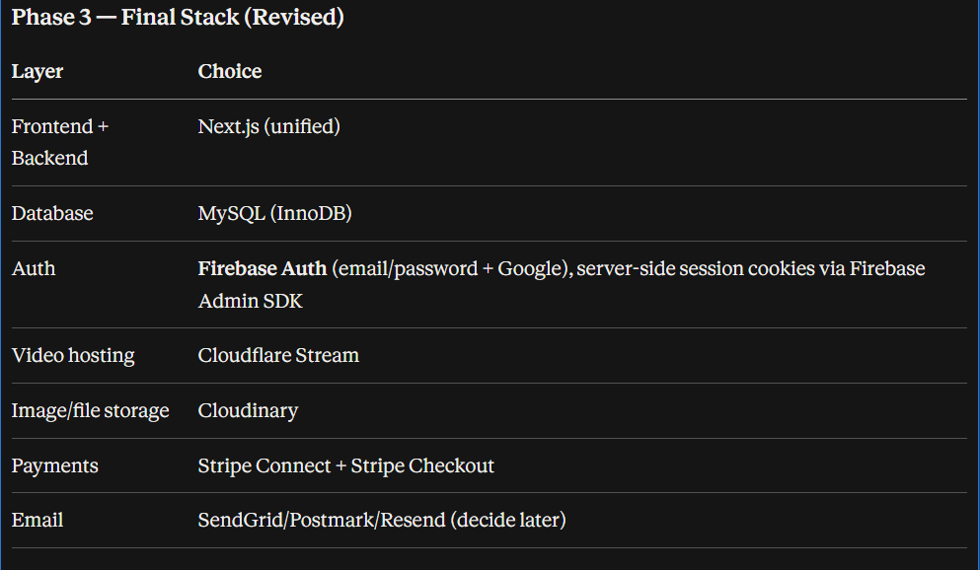
- Rate-limit auth endpoints (login, password reset) to prevent brute force.

PHASE 4 — DATABASE DESIGN
Goal of this phase
Translate every functional requirement from Phase 2 into concrete tables, relationships, and constraints. This is where vague ideas like "track progress" or "instructor payouts" become actual columns with actual data types and actual foreign keys that MySQL will enforce for you.
Why this comes before API design
Your API endpoints are, in large part, just controlled doors into this schema. If the schema is wrong or incomplete, you'll be retrofitting API routes later to work around missing tables/columns. Get the data model right first.
Why this comes before API design (cont'd) — normalization note
MySQL/InnoDB is relational, so we default to normalized design (no duplicated data, relationships via foreign keys) — this matches your Phase 3 reasoning for why we didn't pick MongoDB. We'll only denormalize deliberately, in specific spots, for read performance (I'll flag exactly where and why).

Entities Overview
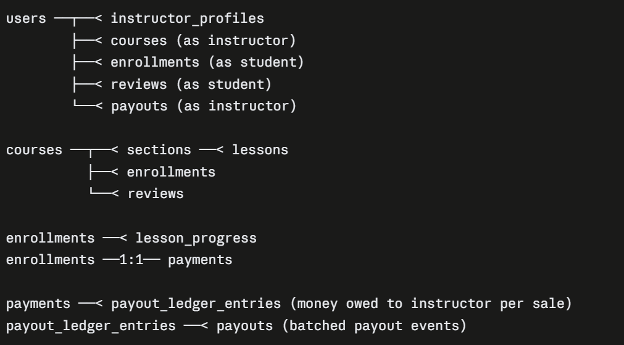

Core Tables => On File
Money Tables — the part that needs the most care
This is where a badly-designed schema costs you real money later. I'm giving this extra weight because you specifically chose automated Stripe Connect payouts, which means correctness here isn't optional.
Why three tables instead of one payments table (this is a decision worth explaining, not just presenting): a single payment creates money owed to an instructor, but payouts happen in batches (Stripe/most platforms don't do a payout per individual sale — that's expensive in fees and impractical). The ledger table lets you accumulate multiple payments into one payout cleanly, and gives you an audit trail: for any dollar paid to any instructor, you can trace it back to the exact sales that funded it. This is what a financial audit or a disputed payout requires — "just store a running balance number" (a common beginner shortcut) is not it. Balances should always be derived from the ledger, never stored as a mutable single number, so a bug can never silently corrupt someone's earnings.
Idempotency note: stripe_payment_intent_id and stripe_transfer_id are UNIQUE constraints — this protects you if a Stripe webhook fires twice (which happens in production, it's expected behavior, not a bug), so your backend logic must be written to safely no-op on a duplicate webhook rather than double-crediting an instructor. I'll flag this again in Phase 5 when we design the webhook handler.

Indexes (beyond primary/foreign keys)
Table | Index | Why
courses | (status, category_id) | course browse/filter is your highest-traffic query
courses | FULLTEXT(title, description) | for search (MySQL has native FULLTEXT — fine for MVP scale, don't reach for Elasticsearch yet)
enrollments | (user_id) | "my courses" dashboard query
payout_ledger_entries | (instructor_id, status) | payout batching job needs "all pending entries for instructor X" fast
Common beginner mistake flagged here
Storing money as FLOAT/DECIMAL with rounding assumptions, or worse, as a string. Floats introduce rounding errors that compound over thousands of transactions — I used INT (cents) throughout for exactly this reason. This is a standard, boring, correct pattern — don't get clever with money columns.
Security consideration
No table stores raw card data (Stripe handles that entirely — you only ever store Stripe's IDs/references). This keeps you out of PCI-DSS scope almost entirely, which is a deliberate architectural benefit, not an accident.
Scalability consideration
avg_rating/review_count on courses and progress_percent on enrollments are intentionally denormalized (cached/derived values) because recalculating them from scratch on every page view doesn't scale. They're updated via application logic whenever a review is added or a lesson is completed — this is a deliberate, common trade-off (read-optimized denormalization on non-financial data), different from the ledger tables where I insisted on normalization because that data is money.
4. Reorder two blocks (the actual bug that would've broken the script)
Physically move these two full CREATE TABLE blocks earlier in the file:
- Cut the entire CREATE TABLE payments (...) block → paste it right before CREATE TABLE enrollments
- Cut the entire CREATE TABLE payouts (...) block → paste it right before CREATE TABLE payout_ledger_entries
Nothing inside either block changes — just their position in the file.
One more small thing while you're in there
Since you now have deleted_at on courses and users, remember going forward: your application code (Phase 5, the API) must never run a real DELETE on these two tables — "deleting" a user or course means UPDATE ... SET deleted_at = NOW(), and every query that lists courses/users must filter WHERE deleted_at IS NULL. I'll make sure this is explicit when we design those endpoints in Phase 5, so it doesn't get forgotten.

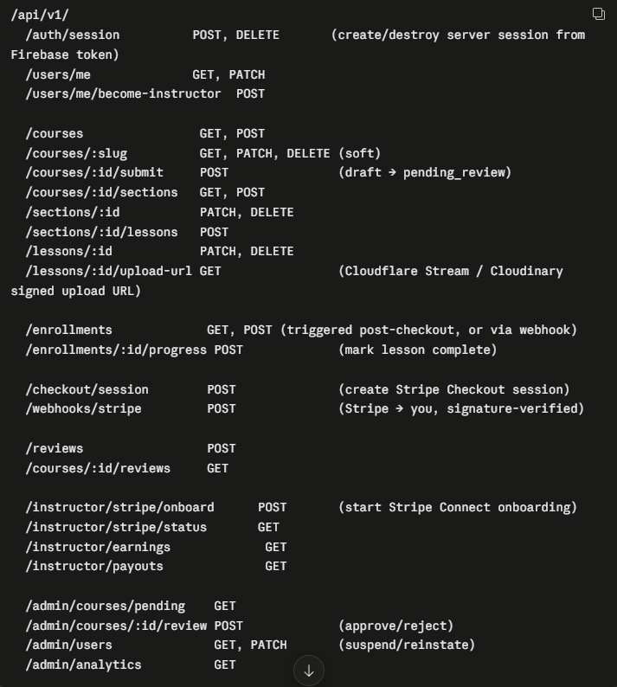
PHASE 5 — BACKEND API DESIGN
Goal of this phase
Define every "door" into your system — what a client can ask for, what it gets back, how errors are communicated, and how requests are secured. This turns your Phase 4 tables into something a frontend (or Stripe, or Cloudflare) can actually talk to.
Why this comes before frontend planning
Phase 7 (frontend) will build screens that call these exact endpoints. If the API contract isn't nailed down now, you'll end up improvising endpoints mid-frontend-build, which is how APIs end up inconsistent (some routes return {data: ...}, others return the raw object, etc.) — a classic sign of no upfront API design.

Route Structure & Versioning
Recommend prefixing everything under /api/v1/... from day one — not because you need multiple versions now, but because retrofitting versioning after clients (your own frontend, or a future mobile app) depend on unversioned routes is painful. This is a 30-second decision now that saves real pain later.
Design principle: REST-ish, resource-based, boring on purpose
Notice nothing here is clever — nouns for resources, HTTP verbs for actions, nested routes for clear ownership (/courses/:id/sections). Common beginner mistake: inventing action-named endpoints like /getCourseById or /updateUserRole — this isn't wrong exactly, but it fights REST conventions and makes the API harder to reason about at scale. Stick to boring REST unless you have a specific reason not to.
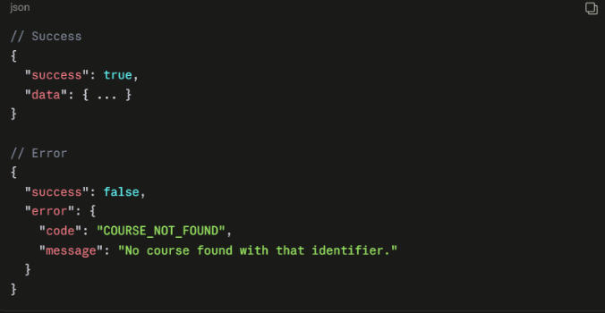
Request/Response Format — pick a shape and never deviate
Every response, success or error, follows one envelope:
Why this matters: your frontend can write one generic error-handling function instead of guessing the shape per-endpoint. Inconsistent response shapes across an API is one of the most common sources of frontend bugs in projects built without this decided upfront.
HTTP status codes — use them correctly, don't return 200 for everything
Code | When
200 | 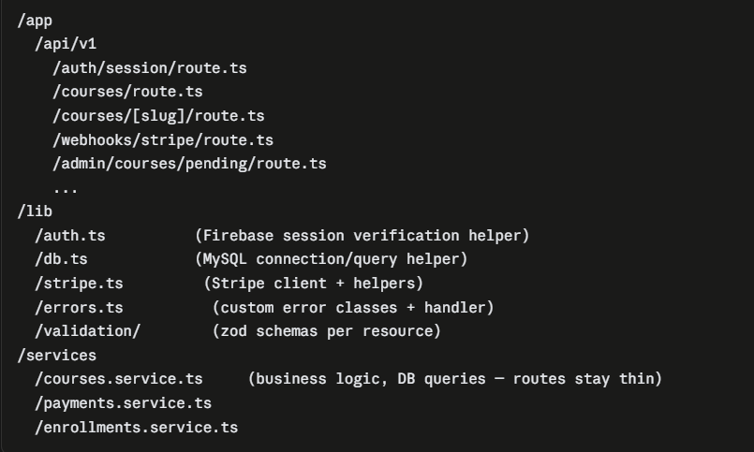  success (GET/PATCH)
201 | resource created (POST)
400 | validation failure (bad input)
401 | not authenticated (no/invalid session)
403 | authenticated but not authorized (e.g., student hitting an admin route)
404 | resource doesn't exist (or soft-deleted — treat the same)
409 | conflict (e.g., trying to enroll in a course you're already enrolled in)
500 | unhandled server error
Common beginner mistake: returning 200 OK with {success: false} for everything. This breaks HTTP semantics, breaks caching, and makes debugging via network tab harder. Use real status codes.

Validation
Every route that accepts input needs schema validation before touching the database — recommend a library like zod (pairs naturally with TypeScript/Next.js) to define the expected shape of each request body once, and reuse it for both runtime validation and TypeScript types.
Example of what needs validating (conceptually, no code yet):
- POST /courses — title required, non-empty; price_cents must be positive integer; category_id must reference a real category
- POST /checkout/session — course_id must exist, must be published, user must not already be enrolled (return 409 if so)
- POST /enrollments/:id/progress — lesson_id must belong to a lesson within the enrolled course (prevents a student marking progress on a course they never bought)
Security note tied to validation: never trust instructor_id or user_id from the request body — always derive it from the authenticated session (Firebase-verified token → your users row), never from client-supplied data. This is the single most common authorization bug in beginner APIs — someone forges a request body with someone else's user_id.

Authentication/Authorization middleware pattern
Every protected route runs through the same check, conceptually:
Request → verify Firebase session cookie (via Admin SDK)
→ load matching users row (by firebase_uid)
→ attach { id, is_instructor, is_admin } to request context
→ route handler checks required role before executing
→ if check fails → 401 (not logged in) or 403 (logged in, wrong role)
Build this once as shared middleware/helper — don't repeat the Firebase verification logic in every route file. Common beginner mistake: copy-pasting auth checks into every handler, then forgetting to add it to a new route later, silently leaving it unprotected.

The Money-Critical Endpoints — extra care required
POST /checkout/session
- Verify course exists, is published, user isn't already enrolled (409 if so).
- Create a Stripe Checkout Session with metadata: { course_id, user_id } attached — this metadata is how your webhook later knows what was purchased.
- Return the Stripe session URL; do not create the enrollments row here — that happens only after payment is confirmed via webhook (see below).
POST /webhooks/stripe — the most important endpoint in your entire system
- Verify the Stripe signature on every request (Stripe SDK gives you this) — reject anything unsigned/invalid immediately. This prevents anyone from POSTing a fake "payment succeeded" event.
- Handle checkout.session.completed: read metadata.course_id/user_id, look up stripe_payment_intent_id — check if a payments row with this ID already exists first (idempotency — Stripe will resend webhooks, this is expected, not a bug). If not seen before: create payments row, create enrollments row, create payout_ledger_entries row, all in one database transaction (this is exactly why we chose MySQL/InnoDB over Mongo — this needs to be atomic).
- Handle charge.refunded: update payments.status, and correspondingly adjust/reverse the payout_ledger_entries if not yet paid out.
- Handle transfer.paid / payout-related events: update payouts.status.
Why the enrollment isn't created at checkout-session-creation time: the student might abandon checkout, or the payment might fail after redirect. Only a confirmed webhook event is trustworthy. This is the "never trust the client redirect" mistake I flagged back in Phase 3 — now it's concrete: don't create the enrollment when the browser redirects to your /success page; create it only when Stripe's server tells your server the payment succeeded.

Background Jobs (the thing I flagged as unresolved when you picked Next.js as backend)
Two jobs need to run outside a normal request/response cycle:
- Payout batching — periodically (e.g., daily/weekly), gather all pending payout_ledger_entries per instructor, create a payouts row, trigger a Stripe Connect transfer, mark entries included_in_payout.
- Video upload processing status — Cloudflare Stream processes uploads asynchronously; you need to poll or receive a webhook from Cloudflare confirming a video is ready before marking a lesson "playable."
Recommendation: use Vercel Cron (if hosting on Vercel) to hit an internal /api/v1/internal/run-payouts route on a schedule, or a proper queue service (Inngest, Upstash QStash) if you want retries/observability built in. Don't try to run these as long-lived setInterval processes inside a serverless Next.js deployment — serverless functions aren't meant to stay alive; this is a common mistake people make coming from traditional server backgrounds.

File Upload Flow (Cloudflare Stream + Cloudinary)
Neither video nor images should be uploaded through your Next.js server (don't proxy large files through your own API — wastes bandwidth/compute, hits serverless payload limits). Instead:
This keeps large file transfer off your own servers entirely — both services support this "direct upload with signed URL" pattern natively.

Error Handling — centralized, not per-route
Recommend one centralized error handler that catches thrown errors and maps them to the response envelope + correct status code, rather than every route hand-writing try/catch + response formatting. Custom error classes (e.g., NotFoundError, ValidationError, ForbiddenError) thrown from business logic, caught once at the top.

Folder Structure (conceptual, Next.js App Router)
Why services are separate from routes: route handlers should be thin — parse request, call a service function, format response. Business logic (e.g., "what does it mean to enroll a student") lives in services, testable independently of HTTP. Common beginner mistake: putting all logic directly inside route handlers — works fine until you need to reuse that logic elsewhere (e.g., the webhook handler needs the same "create enrollment" logic as a hypothetical admin manual-enroll feature) and you end up copy-pasting.

✅ Phase 5 Checklist
- Route structure defined, versioned (/api/v1)
- Consistent response envelope decided
- Status code usage defined
- Validation strategy decided (schema-based, server-side only trust)
- Auth middleware pattern defined
- Webhook idempotency + atomic transaction handling specified
- Background job strategy decided (cron/queue, not long-lived processes)
- Direct-to-Cloudflare/Cloudinary upload pattern defined (not proxied)
- Folder structure separates routes/services/lib

